CompareStream User Guide

Group 6

April 28, 2018

Team Members
Jacob Brandom
Joel Brandom
Min Xiong
Hamza Chaudhry
Adrian Williams
Kris Berkland

Contents

Contents 2
1 Introduction 3
2 Quick Start Guide 3
3 System Requirements 5
4 Main Scenarios of Use 5
5 Troubleshooting…………………………………………………………………………………………………………………….11

Introduction
The CompareStream application allows users to add Tv shows and streaming services to compare prices with one another to fins the best deals for what shows they want. This document will provide instructions for using the application to add and edit TV shows, services, and networks. It will cover reporting problems, and viewing those reports along with viewing accounts.

Quick Start Guide
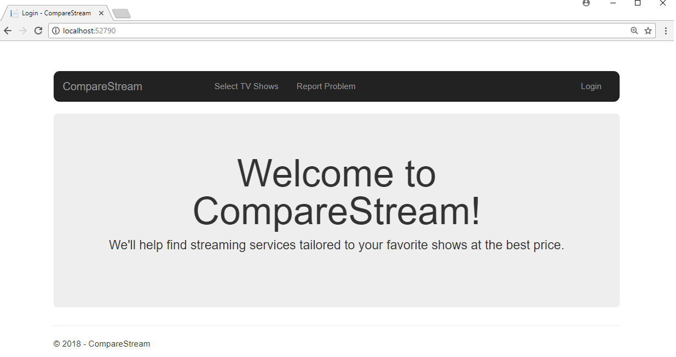
Upon opening CompareStream, You will find a login button. Click this.
- Enter your E-Mail and Password.

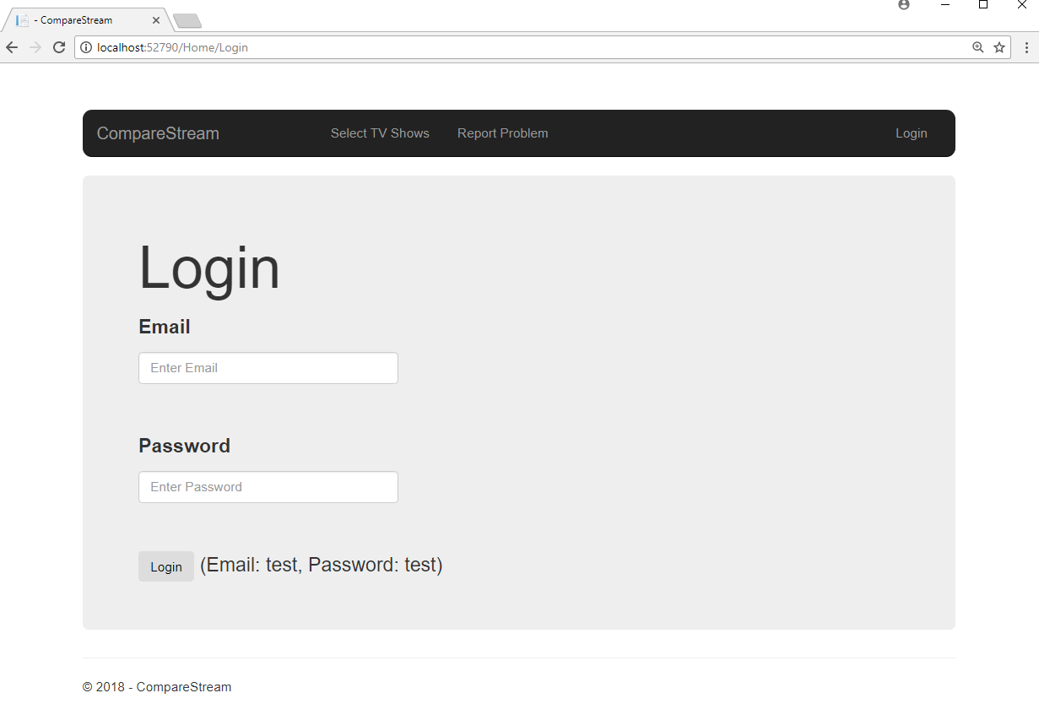

- Tap the Login button.
- You’re in!

System Requirements
The CompareStream application can be ran on any computer using a web browser. Refer to the System Documentation for instructions on installation.

Main Scenarios of Use

Select TV Shows
- Start Compare Stream. Go to the login screen.
- Enter your E-Mail and Password.
- Tap the Login button.
- Tap Select TV Shows in the navbar.

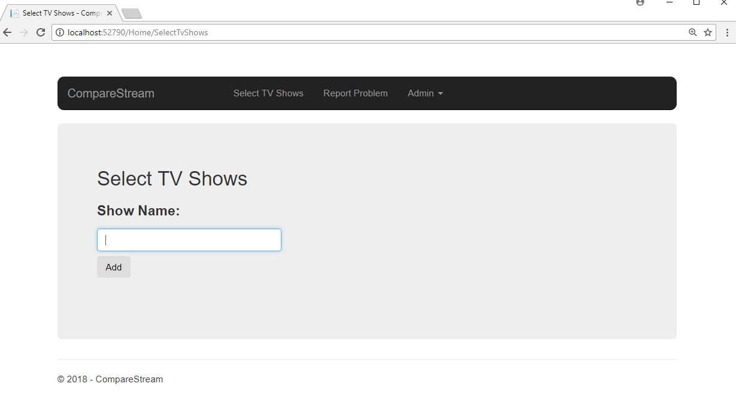
- Type in a show you’d like to add.
- Hit the Add button

Report Problems
- Start Compare Stream. Go to the login screen.
- Enter your E-Mail and Password.
- Tap the Login button.
- Tap Report Problems in the navbar.

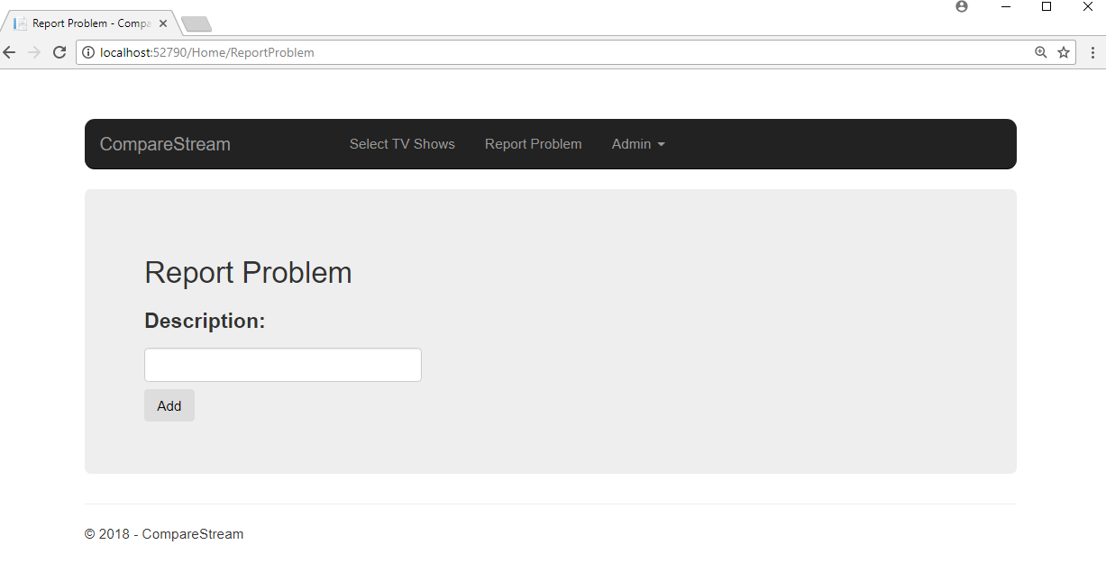

- Enter problem you have found,
- Hit add.

Edit TV Shows
1. Start CompareStream. Go to login screen.
2. Enter Email and password.
3. Tap Login button.
4. Tap Admin drop down menu in navbar
5. Hit Edit TV Shows button

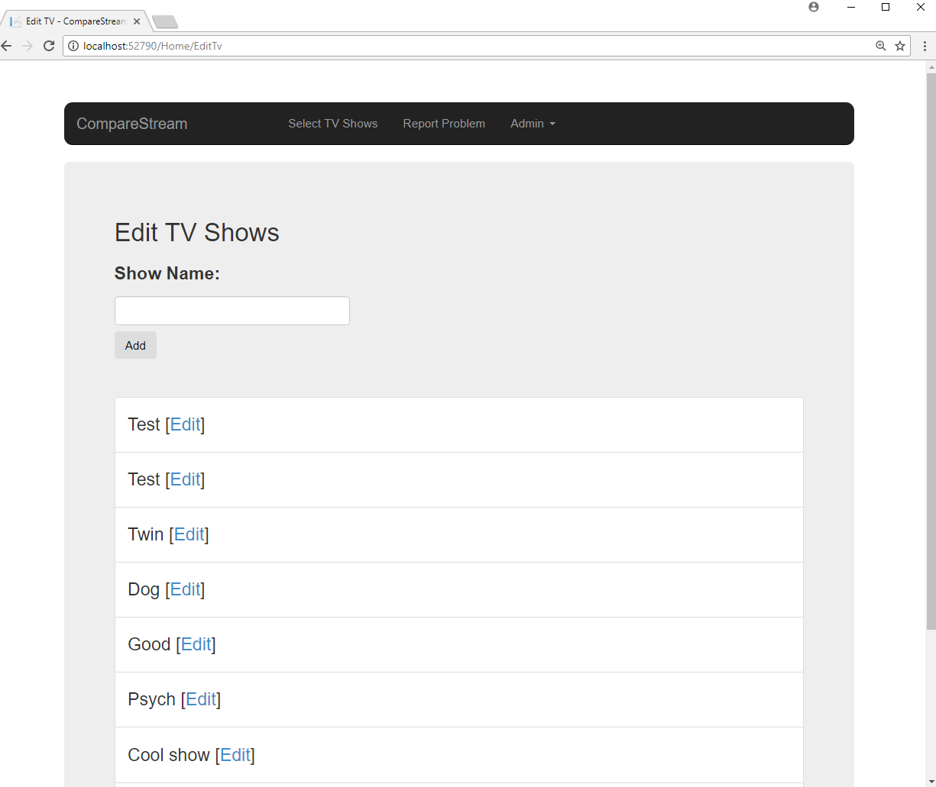
6. Edit listed shows.

Edit Networks
1. Start CompareStream. Go to login screen.
2. Enter Email and password.
3. Tap Login button.
4. Tap Admin drop down menu in navbar
5. Hit Edit Networks button.

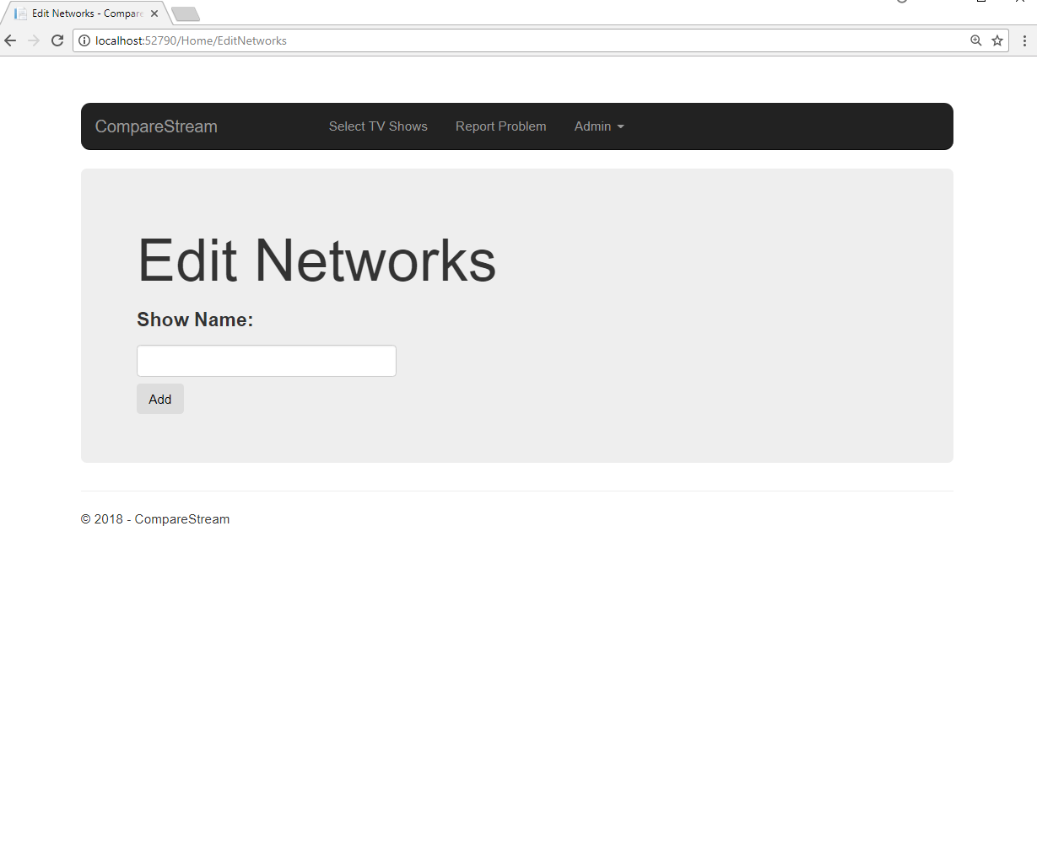

Edit Streaming Services
1. Start CompareStream. Go to login screen.
2. Enter Email and password.
3. Tap Login button.
4. Tap Admin drop down menu in navbar.
5. Hit Edit Streaming Services button.
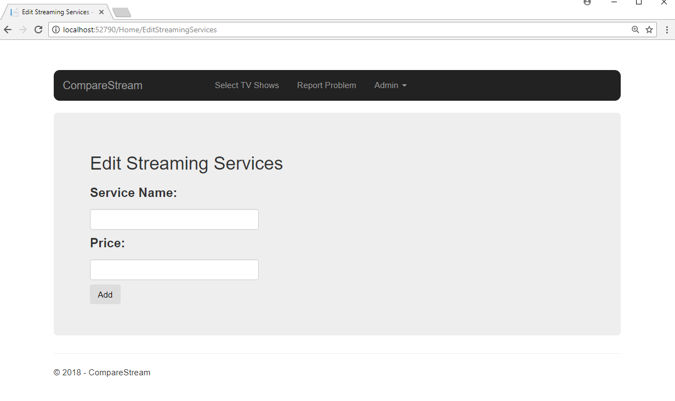
6. Add Service Name.
7. Add price.
8. Hit Add button.

View Accounts
1. Start CompareStream. Go to login screen.
2. Enter Email and password.
3. Tap Login button.
4. Tap Admin drop down menu in navbar.
5. Tap View Accounts button.
6. Enter email you’d like to view
7. Hit search.
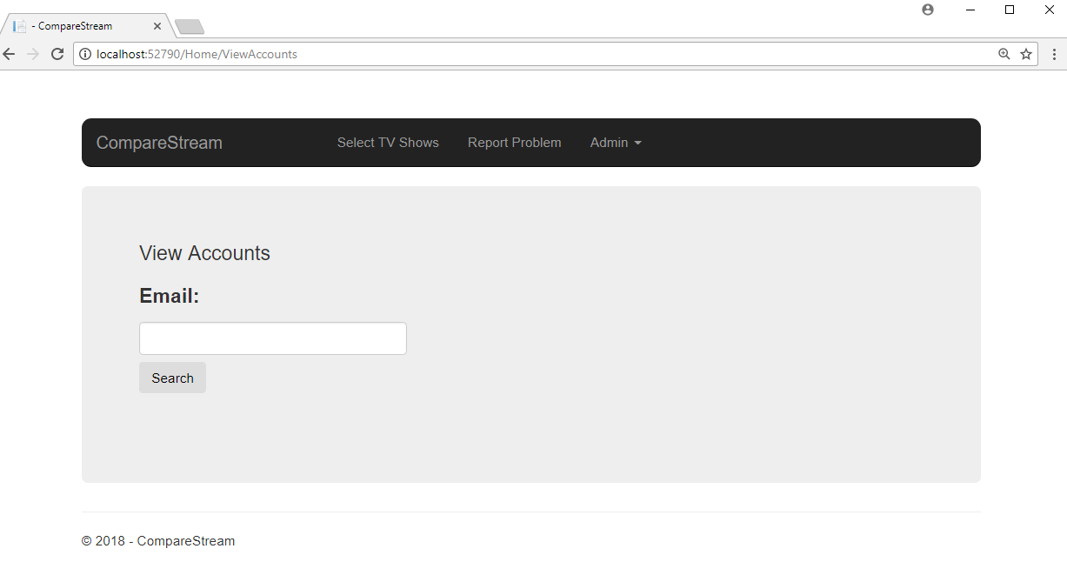

Troubleshooting

Letters in price
A message will be displayed in the event that an impossible price is entered such as letters.
